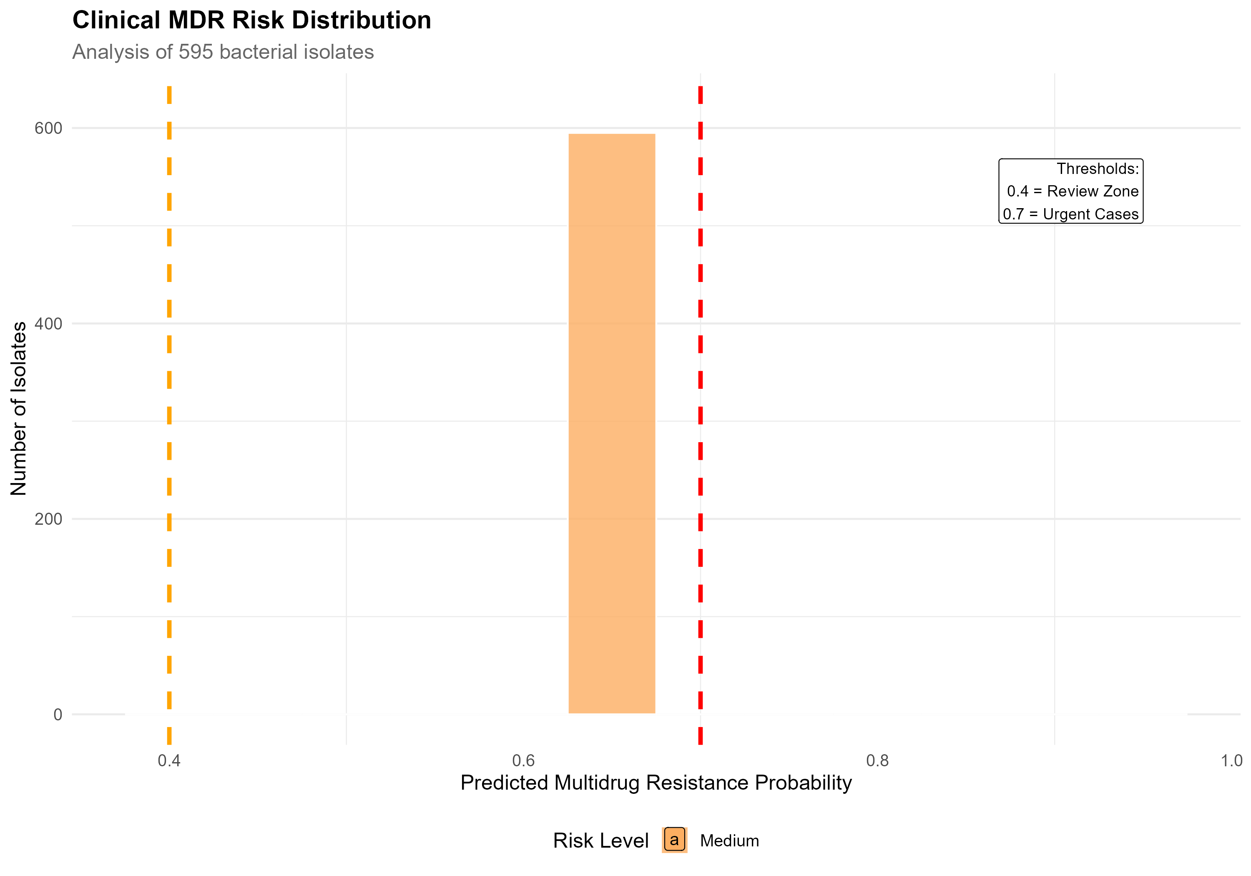

Figure 1: Distribution of MDR Risk Probabilities